**CHAPTER-1**

**INTRODUCTION**

**CHAPTER 1**

**1.INTRODUCTION**

Simplish is an innovative online course platform designed to bridge the gap between learners and educators in the digital age. Our platform enables users to seamlessly register, log in, and purchase courses, while providing educators with the tools to create, manage, and share their expertise. With a focus on user-friendly interfaces, robust security measures, and comprehensive course management features, Simplish aims to revolutionize online education.

Our vision is to create a globally accessible platform where knowledge and education are democratized. We aim to empower learners from all walks of life to achieve their educational goals and foster a community of continuous learning and growth.

Simplish offers a straightforward and secure registration process for both learners and educators. New users can easily sign up by providing essential information such as their name, email address, and a secure password. To enhance security, we implement email verification during the registration process, ensuring that only legitimate users gain access to the platform..

Security is paramount at Simplish. We have implemented a robust authentication system that includes multi-factor authentication (MFA). Users must log in with their correct ID and password, complete a CAPTCHA verification, and enter a one-time password (OTP) sent to their registered email. This multi-layered approach ensures that user accounts are protected against unauthorized access. Educators on Simplish can easily register, log in, and create courses using our intuitive course management system. They can upload course materials, set pricing, and manage course content through a streamlined dashboard. Additionally, educators can interact

**1.2 OBJECTIVE**

The primary objective of Simplish is to create a dynamic and accessible online course platform that serves the needs of both learners and educators. By providing a comprehensive set of features and tools, Simplish aims to:

1. **Enhance Accessibility to Education:**

* Simplish strives to break down geographical and financial barriers to education by offering a wide range of affordable and accessible courses to learners globally.

2. **Support Educators:**

* Simplish is dedicated to empowering educators by offering an easy-to-use platform for course creation, management, and monetization. We provide tools and resources that enable educators to focus on delivering quality education while we handle the technical complexities.

3. **Ensure Security and Privacy:**

We prioritize the security and privacy of our users by implementing robust  **.**

* authentication methods and secure payment systems. Simplish is committed to safeguarding user data and providing a safe online learning environment.

**CHAPTER-2**

**REVIEW OF**

**LITERATURE SURVEY**

**CHAPTER 2**

**2 LITERATURE SURVEY**

The online education sector has witnessed significant growth over the past decade, driven by technological advancements and the increasing demand for flexible learning options. To understand the current landscape and identify best practices for developing Simplish, we conducted a comprehensive literature survey of existing research, platforms, and trends in online education.

**Growth of Online Education**

Research indicates that the global online education market has been expanding rapidly, with projections estimating its value to reach $350 billion by 2025 (Zhao et al., 2020). This growth is attributed to factors such as the proliferation of high-speed internet, the rise of mobile learning, and the increasing acceptance of online credentials by employers.

**Key Components of Successful Online Learning Platforms**

**User Experience and Interface Design**

Studies have shown that the user experience (UX) and interface design play a crucial role in the success of online learning platforms (Hsu et al., 2018). A well-designed interface that is intuitive and easy to navigate can significantly enhance user engagement and satisfaction. Simplish aims to incorporate best practices in UX/UI design to provide a seamless and enjoyable experience for both learners and educators.

**Course Quality and Content Delivery**

The quality of course content is paramount in online education. Research highlights the importance of interactive and multimedia elements in enhancing learning outcomes (Clark & Mayer, 2016). Simplish will leverage various content formats, including videos, quizzes, and interactive modules, to create engaging and effective learning experiences.

The rapid growth of the online education industry has created numerous opportunities for learners and educators alike. However, several challenges persist that hinder the effectiveness and accessibility of online learning. Simplish aims to address these challenges by providing a comprehensive, user-friendly, and secure platform for both learners and educators.

**2.1 Problem Statement**

### Challenges in the Current Online Education Landscape

1. **Accessibility Issues:**
   * Many existing platforms have high costs associated with their courses, limiting access for learners from low-income backgrounds.
   * There is a lack of accessibility features for learners with disabilities, making it difficult for them to engage with course content effectively.
2. **Inconsistent Course Quality:**
   * The quality of courses can vary significantly, particularly on platforms with an open marketplace model. This inconsistency can lead to poor learning outcomes and user dissatisfaction.

**Security and Privacy in Online Education**

With the rise of online learning, concerns about data security and privacy have also increased. Research emphasizes the need for robust security measures to protect user data and ensure the integrity of online transactions (Nguyen et al., 2020). Simplish implements multi-factor

**2.2 Existing System:**

## Existing System

### Overview of Current Online Learning Platforms

The current landscape of online learning is populated by various platforms, each with its own strengths and weaknesses. Prominent examples include Coursera, Udemy, and Khan Academy. While these platforms have made significant contributions to the field of online education, they also exhibit several limitations that Simplish aims to overcome.

### Coursera

#### Strengths:

* **High-Quality Courses:** Coursera partners with top universities and institutions to offer high-quality courses, specializations, and degree programs.
* **Certification:** Learners can earn certificates and degrees that are recognized by employers and academic institutions.
* **Wide Range of Subjects:** A broad array of subjects and disciplines are covered, catering to diverse learning needs.

#### Weaknesses:

* **High Cost:** Many courses and programs on Coursera are expensive, creating a financial barrier for some learners.
* **Limited Interactivity:** While the platform offers video lectures and quizzes, the level of interactivity and engagement in many courses is limited.

### Udemy

#### Strengths:

* **Affordability:** Udemy offers a wide range of courses at relatively low prices, making education more accessible.

**2.3 Proposed System:**

Simplish is designed to address the limitations and challenges identified in existing online learning platforms by providing a comprehensive, user-friendly, and secure environment for both learners and educators. The proposed system aims to enhance accessibility, ensure high-quality course delivery, and foster a collaborative learning community.

**1. Enhanced Accessibility**

**Affordability:**

* Simplish will offer a range of free and affordable courses to ensure that learners from diverse financial backgrounds can access quality education. Additionally, we will provide **2. Consistent Course Quality**

**Curated Course Content:**

* Simplish will employ a rigorous vetting process for course content to ensure high standards. Courses will be reviewed by subject matter experts before being made available to learners.

**Interactive Learning:**

* The platform will incorporate multimedia elements, including videos, quizzes, interactive simulations, and discussion forums, to enhance learner engagement and retention.

**CHAPTER-3**

**COMPANY OVERVIEW**

**CHAPTER 3**

**COMPANY OVERVIEW**

**3. INTRUDUCTION**

Athreya Technologies is a Bangalore based Company who has experience in vast areas of Technology with individuals being full stack developers. Along with the Technical Expertise Athreya Technologies with rich industry expertise in handling R&D teams associated with $150M Revenue and team sizes as large as 200 plus engineers. The team has experience in people program and project management of medium to large Products from various models starting from waterfall to scaled Agile.Athreya Technologies have a team of experts who are here to help you develop Successful software’s to make your workflows simple.

* A director of operations and finance is in charge of overseeing and spearheading business and financial operations, ensuring efficiency and smooth workflow. Their responsibilities revolve around performing research and analysis to identify the best practices to optimize operations, coordinating with different departments to gather data, conducting research and analysis to identify new business and investment opportunities, and monitoring the progress of various projects and programs.
* Finance operations directors also may supervise budget development, financial reporting, and systems management, as well as finance staff, while driving business processes to improve efficiency and meet organizational goals.

Depending on the employer and industry, the finance operations director may approve credit and billing terms for contracts. In addition, they may be responsible for managing internal systems used for recording revenue and compliance with tax and regulatory requirements

**3.1 VISION AND MISSION OF ATHREYA TECHNOLOGIES**

**Vision**

* Unleashing the power of innovation and software to make life simple. There by creating a world class-innovation center and a dedicated employer.

**Mission**

* To provide Jobs, Technology and Coaching to the aspiring candidates along with achieving our business vision and becoming profitable business.

**Values**

* Athreya Technologies believe in the following core values (QSTTI)
* Quality

• Simplicity

• Team up to win

• Trust and Integrity

* All the staff members have been covered through workshops to give complete insights of the group values.
* These values provide strong foundation on which our practices and business decisions are based.

# 3.2 Project,ProgramandPeopleManagement

AlongwiththeTechnicalExpertiseAthreyaTechnologieswithrichindustryexpertisein handling R&D teams. The team sizes as large as 200 plus engineers. The team hasexperience in people program and project management of medium to large Productsfromvarious models starting from waterfalltoscaledAgile.

Athreya Technologies have a team of experts whoare here to help you developSuccessful software’stomakeyour workflowssimple

# Knowledge

Asorganization develops,fundstobereservedtowardscoachingstudentsfromruralcolleges, help them establish themselves as leaders.We are individuals with over20+yearsofindustryexperience.

We are starting with the software services to create the continuous flow of funds torunthe organization. here are many ideas we have, needs additional hands and freshmindstocreateconceptsandimplement.

## SoftwareServices&Solutions

OnboardtheDigitalTransformationjourneythattheglobeiswitnessingwithservicesand solutions provided to various platforms for example AEQUS and HDMC to start

# 3.2.1 HereishowAthreyaTechnologiesplantogrowinpeople

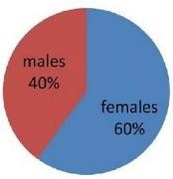

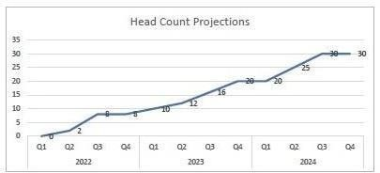

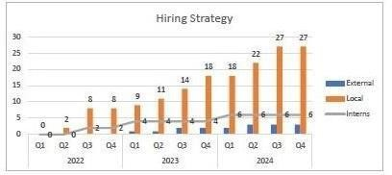

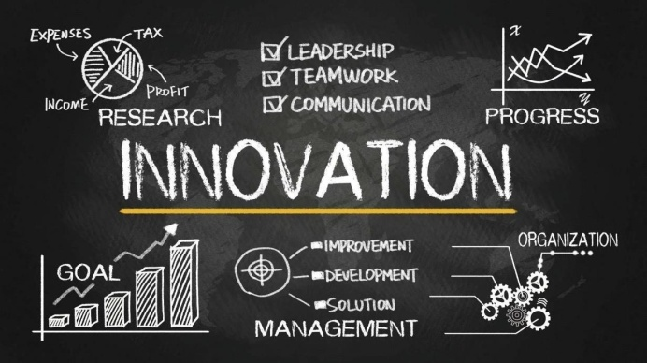Figure 1

Innovation in progress" in Athreya technologies refers to the ongoing developmentand implementationofnewideas,methods,processes,orproductswithinanorganization.

# 3.2.2 InnovationsinProgress

Figure 2

# 3.2.3 ORGANIZATIONSTRUCTURE

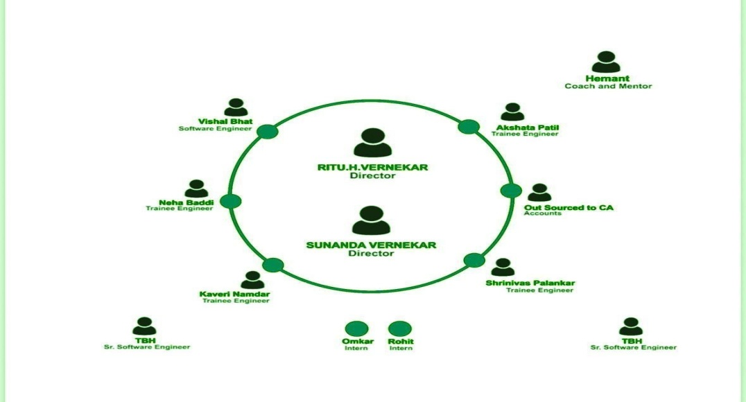AthreyaTechnologiesbelieveinaleanorganizationstructure.Leanorganizationfor2023/24execution.

Figure 3

**3.2.4 PRODUCTSANDMARKETPERFORMANCE**

TheCompanyarereleasethefollowingproducts.

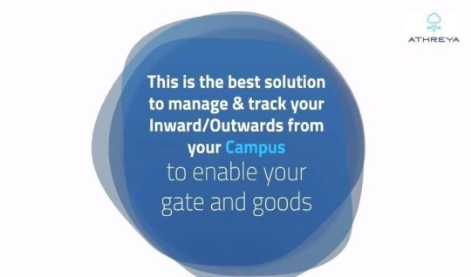**aGate:**A simplesolutionfortheinwardandoutwardmovementofgoodsforlargecampuseslikemanufacturing units,SEZsetc.

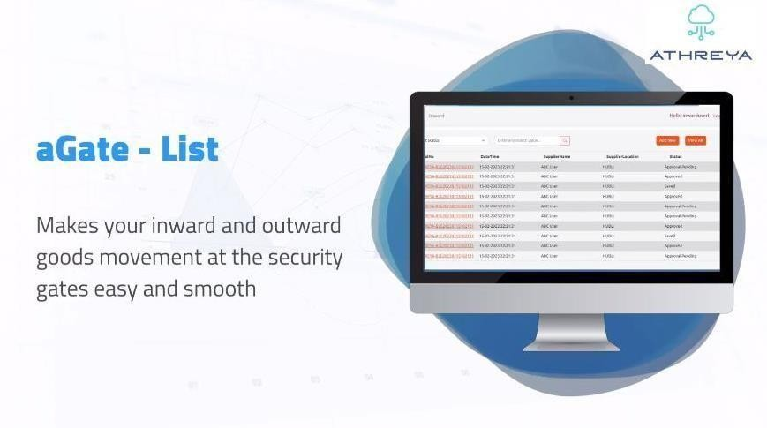 figure 4

figure 5

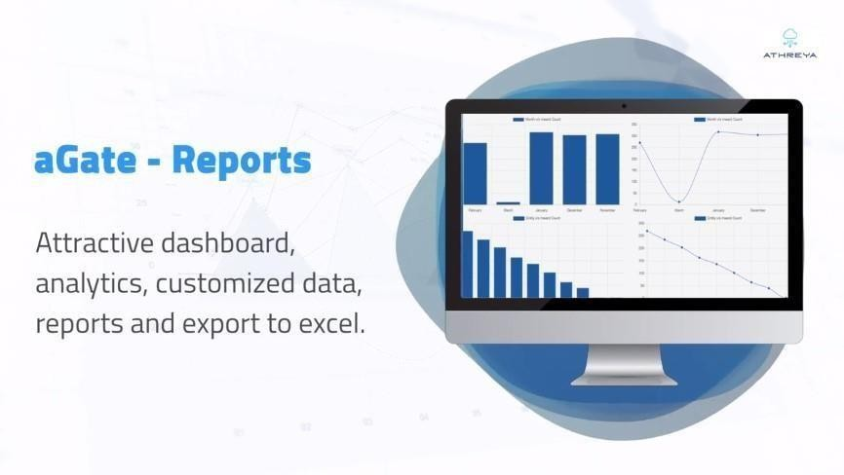

figure 6

figure 7

# 3.2.5 Following are the innovative Products that are currentlybeingdeveloped.

* **Rootkits:**Asimpletooltotrackemployee’sactivityin systemisRootkit.Itisasoftware which put on a computer. The Rootkit monitors the keystrokes on theoperatingsystemyouareusing,checkingthepathseachkeystrokegoesthrough.Inthisway,aRootkit cankeep trackofyour keystrokesand recordeachone
* **Incubator:**Solutiontomanageincubationcentersandrentalspacesforindustrialcampuses.
* **ICafe:** Patentable idea to make cafeterias intelligent and efficientapart fromthis team is in ideation state for two ideas that cannot besharedatthismoment

**CHAPTER-4**

**SYSTEM REQUIREMENT**

**CHAPTER 4**

**SYSTEM REQUIRMENT**

**HARDWARE REQUIREMENTS**

|  |  |
| --- | --- |
| Processor | Intel I3 |
| RAM | 4 GB |
| HDD | 20 GB |

**SOFTWARE SPECIFICATIONS**

IDC visual studio code

Operating System                           Windows 10 Above

Front End                                         HTML, CSS

Web Server CLOUD SERVER

Network High-speed internet connection

**CHAPTER-5**

**DEVELOPMENT ENVIRNOMENT**

**CHAPTER 5**

**5.1 SELECTED LANGUEGES**

**5.1.1HTML 4 AND HTML 5**

HTML 4 is a previous version of the HTML standard, which was widely used before the introduction of HTML5. When working with HTML 4 for a project, consider the following key aspects:

**Document Structure:** In HTML 4, use elements like <header>, <nav>, and <footer> sparingly or resort to traditional <div> elements for structural organization, as semantic elements were not available.

**Multimedia Handling:** To embed multimedia content, use <embed>, <object>, or third-party plugins (like Flash) since the native <video> and <audio> elements were not part of HTML 4.

**Graphics and Animations:** For creating graphics and animations, consider using technologies like GIF, Flash, or CSS animations, as the <canvas> element was not available in HTML 4.

**Forms:** Use <form> elements and traditional input types (e.g., <input type=”text”>, <input type=”checkbox”>, etc.) for form creation and validation.

**Offline Capabilities:** Offline support was limited in HTML 4, and developers often used cookies and server-side technologies for maintaining session data.

**Relocation and Real-time Communication:** HTML 4 did not provide built-in APIs for relocation or Web Sockets; developers had to rely on external scripts and plugins for such functionalities.

**Web Workers:** HTML 4 lacked the Web Workers API, making background processing and improved performance more challenging.

**Accessibility:** While accessibility practices were encouraged, HTML 4 lacked specific semantic elements to enhance accessibility as in HTML5.

HTML 4 was a significant step forward in web development, but it had limitations that HTML5 addressed. If you are working with HTML 4 for a project, consider the constraints it imposes and consider upgrading to HTML5 to leverage its enhanced features and capabilities for a more modern and robust web development experience.

**HTML5** (HyperText Markup Language 5) is the latest version of the standard markup language used to create and structure content on the web. It builds upon previous versions of HTML, introducing new elements, attributes, and APIs that enhance the capabilities of web development. Here’s a brief explanation of HTML5’s key features:

**Semantic Elements:** HTML5 introduced several semantic elements (e.g., <header>, <nav>, <main>, <footer>, etc.) that help define the structure and meaning of content, making it easier for search engines and screen readers to understand the page’s layout.

**Multimedia Support:** HTML5 provides native support for multimedia elements like <video> and <audio>, enabling developers to embed videos and audio content directly into web pages without relying on third-party plugins (like Flash).

**Canvas:** The <canvas> element allows developers to create dynamic and interactive graphics and animations directly within the browser, using JavaScript to manipulate the drawing context.

**Form Enhancements:** HTML5 introduced new input types (e.g., <email>, <url>, <date>, etc.) and attributes, making it easier to develop user-friendly and mobile-friendly forms with built-in validation.

**Offline Web Applications:** HTML5 introduced the Application Cache and Web Storage API, allowing web applications to store data locally and work offline, even without an active internet connection.

**WebSockets:** HTML5 introduced WebSockets, a communication protocol that enables real-time, bidirectional communication between the client and server, facilitating interactive and dynamic web applications.

**Improved Accessibility:** With the introduction of semantic elements and other accessibility features, HTML5 helps developers create more accessible web content for users with disabilities.

Overall, HTML5 provides a more powerful and flexible foundation for web development, enabling developers to create rich, interactive, and user-friendly web applications and websites.

**5.1.2 CSS**

**Introduction:** CSS is a style sheet language used to control the presentation and layout of HTML documents.

**Styling HTML Elements:** CSS allows you to apply styles to HTML elements, such as setting colors, fonts, margins, padding, and more.

**Selectors:** CSS selectors are used to target HTML elements and apply styles. Common selectors include element selectors, class selectors (.class-name), and ID selectors (#element-id).

**Box Model:** The CSS box model describes how elements are rendered on the web page, including content, padding, borders, and margins.

**Layout:** CSS provides various layout techniques, such as using floats, positioning (position: relative/absolute/fixed), and CSS Grid or Flexbox for more advanced layouts.

**Pseudo-classes and Pseudo-elements:** CSS pseudo-classes (:hover, :active, etc.) and pseudo-elements (::before, ::after, etc.) allow you to target and style elements based on their state or position.

**CSS Preprocessors:** CSS preprocessors like Sass and Less extend CSS with variables, nesting, functions, and more, enhancing code maintainability.

**CSS Frameworks:** Popular CSS frameworks like Bootstrap and Foundation provide pre-designed CSS components and layout grids, speeding up web development.

**Browser Compatibility:** Different web browsers may render CSS slightly differently, so it’s essential to test and ensure cross-browser compatibility.

**CSS Best Practices**: Following best practices, like using external CSS files, minification, and optimizing selectors, helps maintain a clean and efficient codebase.

CSS plays a critical role in web development, allowing developers to create visually appealing and consistent designs, ensuring a better user experience across different devices and browsers.

**CHAPTER-6**

**SYSTEM DESIGN**

**CHAPTER 6**

**SYSTEM DESIGN**

Designing a system for e-learning involves several key components to ensure it is effective, scalable, and user-friendly. Here's an introduction to the system design of an e-learning platform

### 1. ****User Roles and Authentication****

* **User Roles:** Define different roles such as students, instructors, administrators, and possibly parents or guardians.
* **Authentication:** Implement secure login mechanisms, possibly including multi-factor authentication for enhanced security.

### 2. ****Course Management****

* **Course Creation:** Allow instructors to create courses with modules, lessons, quizzes, assignments, and resources.
* **Course Enrollment:** Provide a way for students to browse courses, enroll in them, and track their progress.

### 3. ****Content Management****

* **Multimedia Support:** Support various types of content like videos, documents, presentations, and interactive simulations.

**Presentation Layer (Frontend)**

Developed using HTML for structure and CSS for styling, this layer focuses on

rendering the user interface of our e-learning platform.. Key features include

coureses, navigation menus, and informative pages, all crafted to enhance user

interaction and accessib

**CODING**

**<html lang="kn">**

**<head>**

**<meta charset="UTF-8">**

**<meta name="viewport" content="width=device-width, initial-scale=1.0">**

**<title>Document</title>**

**<link rel="stylesheet" href="style.css">**

**<link rel="stylesheet" href="https://cdnjs.cloudflare.com/ajax/libs/font-awesome/6.5.2/css/all.min.css">**

**</head>**

**<body>**

**<div class="navbar">**

**<div class="icon">**

**<h2 class="logo">ED study</h2>**

**</div>**

**<div class="menu">**

**<ul>**

**<li><a href="index.html">HOME</a></li>**

**<li><a href="ABOUT.html">ABOUT</a></li>**

**<li><a href="COURSE.html">COURES</a></li>**

**<li><a href="CONTACT.html">CONTACT</a></li>**

**<li><a href="LOGIN.html">LOGIN</a></li>**

**</ul>**

**</div>**

**</div>**

**<div class="welcome">**

**<div class="text">**

**<h1>CONTACT US</h1>**

**</div>**

**</div>**

**<div class="call">**

**<div class="contact-info">**

**<div class="cat">**

**<div class="time"><i class="fa-solid fa-address-book"></i></div>**

**<div class="date">**

**<h2>Address</h2>**

**<p>489 suiiud uii ui <br>rijj riur,ruirrcr, <br>3445566</p>**

**</div>**

**</div>**

**<div class="cat">**

**<div class="time"><i class="fa-solid fa-phone"></i></div>**

**<div class="date">**

**<h2>phone</h2>**

**<p>3445566</p>**

**</div>**

**</div>**

**<div class="cat">**

**<div class="time"><i class="fa-solid fa-envelope"></i></div>**

**<div class="date">**

**<h2>Email</h2>**

**<p>fjkdfimki@email.com</p>**

**</div>**

**</div>**

**</div>**

**<div class="frombox">**

**<form>**

**<h2>Send Message</h2>**

**<div class="inputbox">**

**<input type="text" name="" required="required">**

**<span>Full Name</span>**

**</div>**

**<div class="inputbox">**

**<input type="text" name="" required="required">**

**<span>Email</span>**

**</div>**

**<div class="inputbox">**

**<textarea required="required"></textarea>**

**<span>Type your Message</span>**

**</div>**

**<div class="inputbox">**

**<input type="submit" name="" value="Send">**

**</div>**

**</form>**

**</div>**

**</div>**

**<div class="bottem">**

**<h4>About us</h4>**

**<p>jksuui uiniuinve jkniuviunev inituihv**

**ergbuibiuntiogiet teiu etuiniuh ijijiojtg teoigjiot <br>**

**tinteiuhjiuoijotjoigtt kniotnio tgioetn einiun bniuib**

**</p>**

**<div class="bottem-iocns">**

**<i class="fa-brands fa-facebook"></i>**

**<i class="fa-brands fa-square-instagram"></i>**

**<i class="fa-brands fa-twitter"></i>**

**<i class="fa-brands fa-linkedin"></i>**

**<p>Made by <i class="fa-solid fa-thumbs-up"></i> Mohammad umar</p>**

**</div>**

**</div>**

**</body>**

**</html>**

**CSS CODE**

**\*{**

**margin: 0;**

**padding: 0;**

**}**

**.navbar{**

**width: 100%;**

**height: 65px;**

**margin: auto;**

**background-color:#fff;**

**position: fixed;**

**top: 0; left: 0; right: 0;**

**z-index: 1000;**

**background: #bde4eb;**

**box-shadow: 0px -5px 13px 10px;**

**display: flex;**

**justify-content: space-between;**

**align-items: center;**

**}**

**.icon{**

**width: 200px;**

**float: left;**

**height: 70px;**

**}**

**.logo{**

**color: #0fb1ce;**

**font-size: 35px;**

**font-family: Arial;**

**padding-left: 20px;**

**float: right;**

**padding-top: 10px;**

**}**

**.menu{**

**width: 400px;**

**float: right;**

**height: 70px;**

**margin-right: 30px;**

**}**

**ul{**

**float: right;**

**display: flex;**

**justify-content: center;**

**align-items: center;**

**}**

**ul li{**

**list-style: none;**

**margin-left: 62px;**

**margin-top: 27px;**

**font-size: 14px;**

**}**

**ul li a{**

**text-decoration: none;**

**color: #0fb1ce;**

**font-family: Arial;**

**font-weight: bold;**

**transition: 0.4s ease-in-out;**

**}**

**ul li a:hover{**

**color: dimgray;**

**}**

**.home{**

**width: 100%;**

**background: url(r1.jpg);**

**background-position: center;**

**background-size: cover;**

**height: 106vh;**

**}**

**.content{**

**min-height: 100vh;**

**display: flex;**

**align-items: center;**

**background-size: cover;**

**background-position: center;**

**}**

**.content .par{**

**margin-left: -348px;**

**margin-bottom: -223px;**

**font-family: Arial;**

**letter-spacing: 1.2px;**

**line-height: 30px;**

**color: #fff;**

**}**

**.content h1{**

**font-family: 'Times New Roman';**

**font-size: 50px;**

**padding-left: 200px;**

**margin-top: -100px;**

**letter-spacing: 2px;**

**color: #fff;**

**}**

**.content .cn{**

**width: 160px;**

**height: 40px;**

**background: #0fb1ce;**

**margin-bottom: -453px;**

**margin-left: -328px;**

**font-size: 18px;**

**border-radius: 10px;**

**cursor: pointer;**

**transition: .4s ease;**

**}**

**.content .cn a{**

**text-decoration: none;**

**color: #000;**

**transition: .3s ease;**

**}**

**.cn :hover{**

**background-color: #0fb1ce;**

**width: 100%;**

**height: 100%;**

**}**

**.content span{**

**color: #0fb1ce;**

**font-size: 60px;**

**}**

**.content2{**

**text-align: center;**

**color: #0fb1ce;**

**background-color: rgb(182, 177, 177);**

**}**

**.cart{**

**width: 100%;**

**height: 400px;**

**}**

**.cart{**

**height: 300px;**

**width: 100%;**

**display: flex;**

**background-repeat: no-repeat;**

**background-size: cover;**

**}**

**.information{**

**width: 100%;**

**margin: auto;**

**text-align: center;**

**padding-top: 40px;**

**}**

**h1{**

**font-size: 36px;**

**font-weight: 600;**

**}**

**p{**

**color: black;**

**font-size: 14px;**

**font-weight: 300;**

**line-height: 22px;**

**padding: 10px;**

**}**

**.row{**

**margin-top: 5%;**

**display: flex;**

**justify-content: space-between;**

**}**

**.information-col{**

**flex-basis: 31%;**

**background: #d3ecf5;**

**border-radius: 10px;**

**margin-bottom: 5px;**

**padding: 20px 12px;**

**box-sizing: border-box;**

**}**

**h3{**

**text-align: center;**

**font-weight: 600;**

**margin: 10px 0;**

**}**

**.information-col:hover{**

**box-shadow: 0 0 20px 0px rgba(0,0,0,0.2);**

**}**

**.facilities{**

**width: 80%;**

**margin: auto;**

**text-align: center;**

**padding-top: 100px;**

**}**

**.fact-row{**

**margin-top: 5%;**

**display: flex;**

**justify-content: space-between;**

**}**

**.fact-col{**

**flex-basis: 31%;**

**border-radius: 10px;**

**margin-right: 5%;**

**text-align: center;**

**width: 60%;**

**display: inline;**

**}**

**.fact-col video{**

**width: 100%;**

**border-radius: 20px;**

**height: 200px;**

**}**

**.comments{**

**width: 80%;**

**margin: auto;**

**padding-top: 100px;**

**text-align: center;**

**}**

**.comm-row{**

**margin-top: 5%;**

**display: flex;**

**justify-content: space-between;**

**}**

**.comm-col{**

**flex-basis: 44%;**

**border-radius: 10px;**

**margin-bottom: 5%;**

**text-align: left;**

**background: #d3ecf5;**

**padding: 25px;**

**cursor: pointer;**

**display: flex;**

**}**

**.comm-col img{**

**height: 40px;**

**margin-left: 17px;**

**margin-right: 5%;**

**border-radius: 50%;**

**}**

**.comm-col p{**

**padding: 0;**

**}**

**.comm-col h3{**

**margin-top: 15px;**

**text-align: left;**

**}**

**.comm-col i{**

**color: #f44336;**

**}**

**SCREENSHOT**



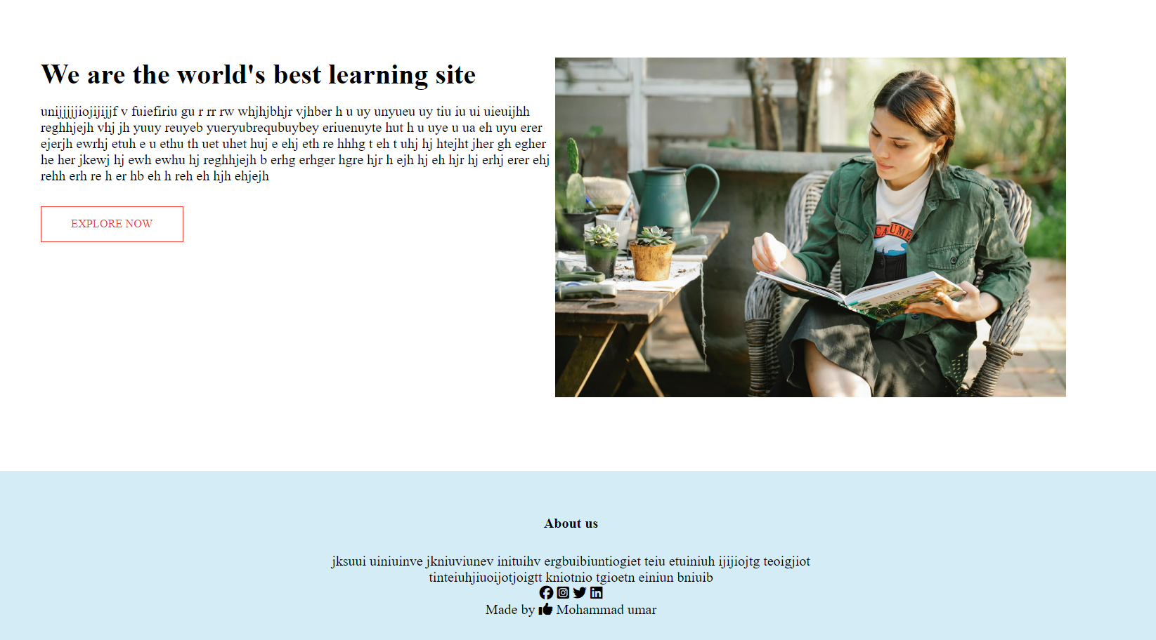

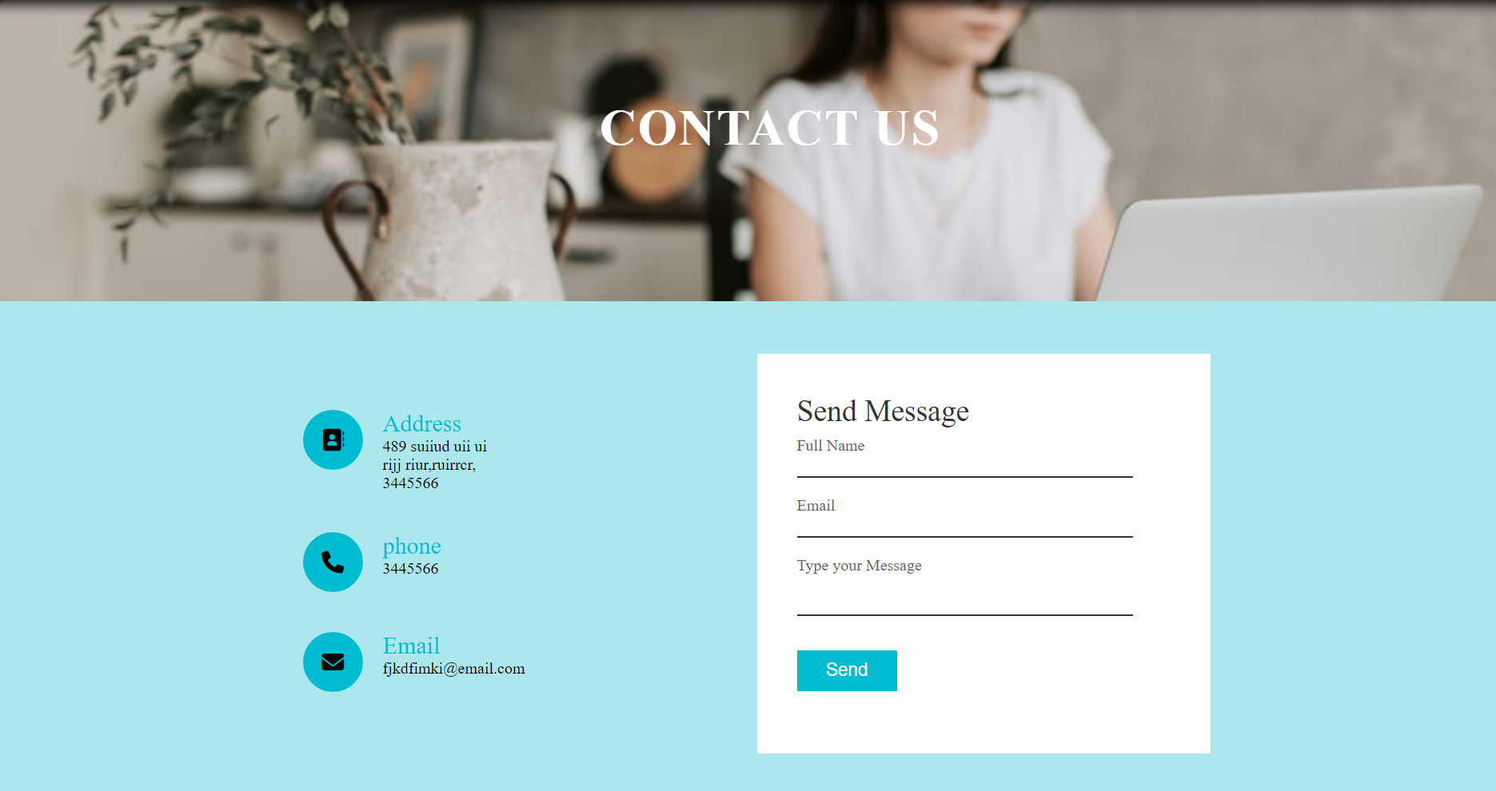

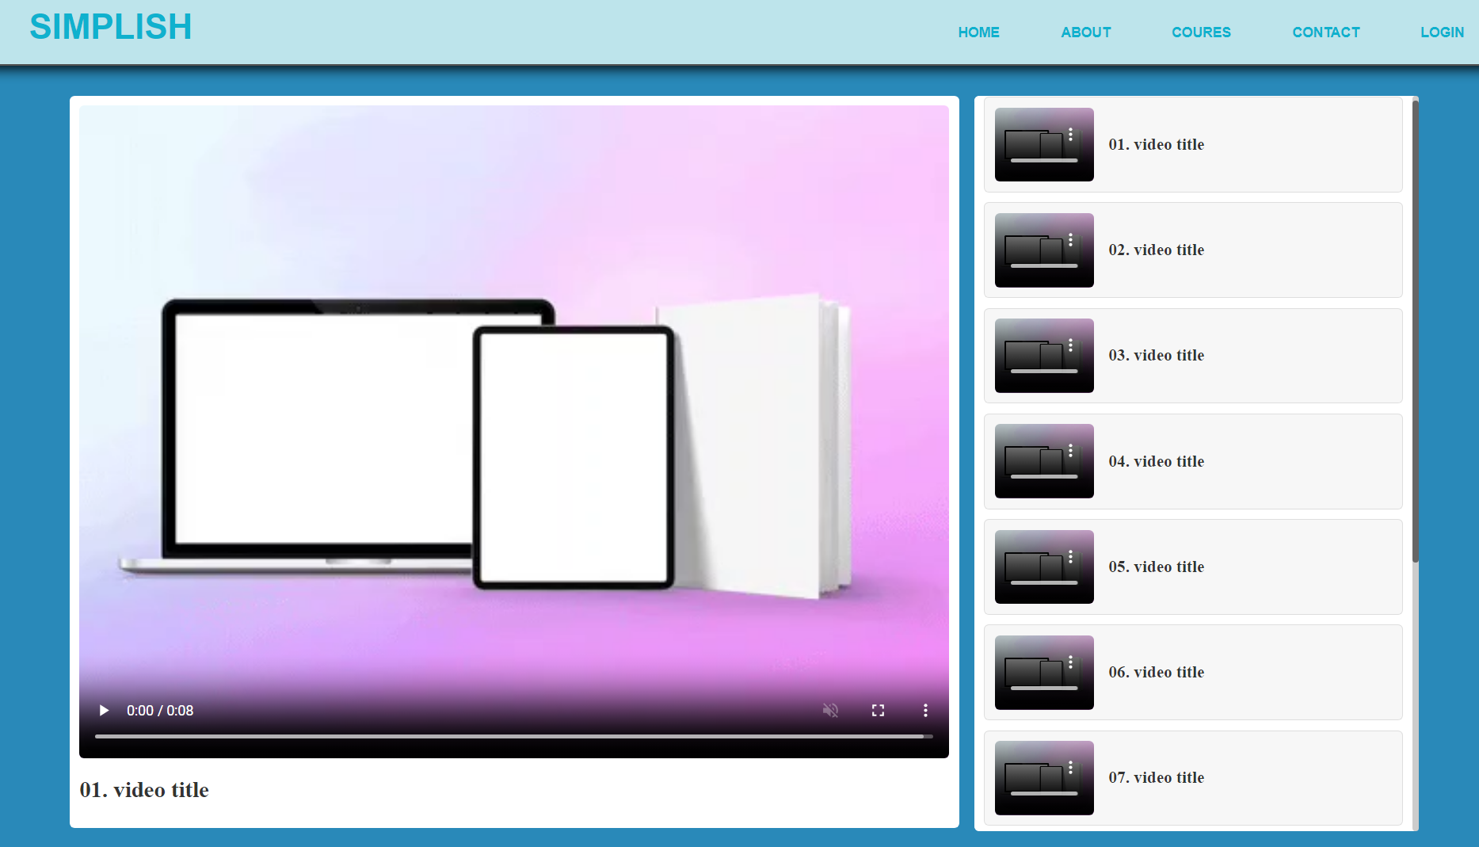

**CHAPTER-7**

**System implementation**

**and TESTING**

**CHAPTER 8**

**TESTING**

The philosophy behind testing is to find bugs. The common view of testing Is that there are no errors in a program. However it is virtually impossible to prove that no program will be free and clear of errors [11]. Therefore the most useful approach and practical approach is with the understanding that testing is the program fail.

Executing a program in a simulated environment performs verification. It is sometimes called Alpha Testing. Validation is the process of using the software in a live environment in order to find errors. It can be called as Beta Testing.

System testing is the stage of implementation, which aims at ensuring that the system works accurately and efficiently before actual operation commences.

No program or system design is perfect; communication between the user and the designer is not always complete or clear, and time is usually short. The result is errors and more errors. The number and nature of errors in a design depend on several factors:

1. Communication between the user and the designer.
2. The programmer’s ability to generate a code that reflects exactly
3. The system specification.
4. The time frame for the design.

**Test strategy and approach**

Field testing will be performed manually and functional tests will be written in detail.

**Test objectives**

* All field entries must work properly.
* Pages must be activated from the identified link.
* The entry screen, messages and responses must not be delayed.

**Features to be tested**

* Verify that the entries are of the correct format
* No duplicate entries should be allowed
* All links should take the user to the correct page.

# INTEGRATION TESTING

# Software integration testing is the incremental integration testing of two or more integrated software components on a single platform to produce failures caused by interface defects.

# The task of the integration test is to check that components or software applications, e.g. components in a software system or – one step up – software applications at the company level – interact without error.

**Integration testing for Database Synchronization:**

* Testing the links that call the Change Username & password, Migration and Synchronization screens etc.
* The username should be retained throughout the application in the form of hidden variables or by using cookies.
* If the login user does not have enough privileges to invoke a screen, the link should be disabled.
* Any modification in the Master server should be reflected in the Slave server.
* The XML file should retrieve only the records, which have been modified.

**Test Results:** All the test cases mentioned above passed successfully. No defects encountered.

**CHAPTER-8**

**Advantages**

**And disadvantages**

**ADVANTAGES**

**1. Enhanced Accessibility**

**Affordability:**

* Simplish offers a range of free and affordable courses, making education accessible to learners from various financial backgrounds. Financial aid and scholarships further support those in need, ensuring that cost is not a barrier to learning.

**Inclusivity:**

* By adhering to Web Content Accessibility Guidelines (WCAG), Simplish ensures that learners with disabilities can fully engage with the platform. Features like screen reader compatibility, closed captions, and adjustable text sizes promote an inclusive learning environment.

**2. Consistent Course Quality**

**Curated Content:**

* Simplish employs a rigorous vetting process for course content, ensuring that only high-quality courses are available to learners. Subject matter experts review all courses, maintaining consistent educational standards across the platform.

**Interactive Learning:**

* The platform integrates multimedia elements, including videos, quizzes, interactive simulations, and discussion forums, to enhance learner engagement and retention. This interactive approach makes learning more enjoyable and effective.

**3. Robust Security and Privacy**

**Multi-Factor Authentication (MFA):**

* Simplish implements multi-factor authentication, providing an additional layer of security for user accounts. This helps protect against unauthorized access and ensures that user data remains secure.

**Secure Payment Systems:**

* By integrating with trusted payment gateways, Simplish ensures that all financial transactions are encrypted and secure, safeguarding users' financial information and enhancing their trust in the platform.

**Data Privacy:**

* Simplish complies with international data privacy regulations, ensuring that user data is handled responsibly and securely. This commitment to privacy builds user confidence and trust in the platform.

**4. User-Friendly Interface**

**Intuitive Design:**

* Simplish features a user-friendly interface that is easy to navigate for both learners and educators. The intuitive design simplifies the process of finding, enrolling in, and managing courses.

**CHAPTER-9**

**FURTURE ENHANCEMENT**

**CHAPTER 9**

**ADVANTAGES**

**1. Enhanced Accessibility**

**Affordability:**

* Simplish offers a range of free and affordable courses, making education accessible to learners from various financial backgrounds. Financial aid and scholarships further support those in need, ensuring that cost is not a barrier to learning.

**Inclusivity:**

* By adhering to Web Content Accessibility Guidelines (WCAG), Simplish ensures that learners with disabilities can fully engage with the platform. Features like screen reader compatibility, closed captions, and adjustable text sizes promote an inclusive learning environment.

**2. Consistent Course Quality**

**Curated Content:**

* Simplish employs a rigorous vetting process for course content, ensuring that only high-quality courses are available to learners. Subject matter experts review all courses, maintaining consistent educational standards across the platform.

**Interactive Learning:**

* The platform integrates multimedia elements, including videos, quizzes, interactive simulations, and discussion forums, to enhance learner engagement and retention. This interactive approach makes learning more enjoyable and effective.

**3. Robust Security and Privacy**

**Multi-Factor Authentication (MFA):**

* Simplish implements multi-factor authentication, providing an additional layer of security for user accounts. This helps protect against unauthorized access and ensures that user data remains secure.

**Secure Payment Systems:**

* By integrating with trusted payment gateways, Simplish ensures that all financial transactions are encrypted and secure, safeguarding users' financial information and enhancing their trust in the platform.

**Data Privacy:**

* Simplish complies with international data privacy regulations, ensuring that user data is handled responsibly and securely. This commitment to privacy builds user confidence and trust in the platform.

**4. User-Friendly Interface**

**Intuitive Design:**

* Simplish features a user-friendly interface that is easy to navigate for both learners and educators. The intuitive design simplifies the process of finding, enrolling in, and managing courses.

**CHAPTER-10**

**CONCLUSION**

**CHAPTER 10**

**CONCLUSION**

Simplish is poised to revolutionize the online education landscape by addressing the limitations and challenges of existing platforms. With a focus on enhanced accessibility, consistent course quality, robust security, and a user-friendly interface, Simplish aims to provide a comprehensive and inclusive learning environment for both learners and educators.

Our commitment to affordability and inclusivity ensures that education is accessible to everyone, regardless of their financial background or physical abilities. By employing a rigorous content vetting process and incorporating interactive multimedia elements, we guarantee high-quality, engaging courses that meet the diverse needs of our users.

The implementation of multi-factor authentication and secure payment systems underscores our dedication to protecting user data and maintaining a secure learning environment. Moreover, our responsive customer support and intuitive design enhance user satisfaction and foster a positive learning experience.

Looking ahead, we are excited about the future enhancements planned for Simplish, including AI-driven personalized learning paths, immersive VR and AR experiences, gamification, and expanded course offerings. These advancements will further enrich the learning experience, making it more engaging, flexible, and effective.

.

**BIBLIOGRAPHY**

1. Oleg Forbatok Published “Premise-Based Construction Cost Estimation In Residential Production In St. Petersburg, Russia by Oleg Forbatok” in 2014 at Aalto University school of Engineering.

2. Neven Martinec published“Cost Estimate For The Construction Of Residential – Commercial Bulidings’’ from pagenumber-233 to 241.

3. Agnieszka Lesniak, Edyta Plebankiewicz published“cost calculation of building structures and building works polish conditions” in 2012 at engineering management research.

* *http://www.google.com*
* *http://www.wikipedia.com*
* *http://www.youtube.com*